STUDENT MANAGEMENT SYSTEM
A Project Report on Python Programming
Submitted by:
Name:
Course :
Subject: Python Programming
Submitted to: VITyarthi
Academic Year: 2026–2027

INTRODUCTION

The Student Management System is a Python-based application developed to manage and organize student information in a simple and efficient way. The system allows users to store student details, manage marks and attendance, search and update records, and generate student reports.
The main purpose of this project is to reduce the effort required to maintain student records manually. Instead of maintaining information in registers, the system provides a single platform where student data can be added, viewed, updated, and managed.
The project uses basic Python concepts such as functions, loops, conditional statements, lists, dictionaries, and file handling. The system is menu-driven, making it simple and easy for the user to operate.

PROBLEM STATEMENT

Managing student records manually can be time-consuming and may lead to errors, duplicate entries, or loss of information. Details such as student names, roll numbers, marks, attendance, and grades need to be maintained properly and updated whenever required.
The Student Management System is developed to provide a simple computerized solution for storing and managing student information. It allows the user to add, view, search, update, and delete student records. The system also provides features for managing marks and attendance and generating student reports.
The project aims to make student record management easier, more organized, and less dependent on manual paperwork.

OBJECTIVES
The main objectives of the Student Management System are:
- To maintain student records in an organized manner.
- To add and store new student information.
- To view student records whenever required.
- To search for student records quickly.
- To update existing student details.
- To delete student records when required.
- To manage and store student marks.
- To calculate percentage and grades.
- To maintain student attendance records.
- To generate a complete student report.
- To reduce the time and effort required for manual record management.

FUNCTIONAL REQUIREMENTS
The functional requirements describe the main operations that the Student Management System should perform.
- Student Registration
The system should allow the user to add a new student by entering details such as student ID, name, age, class, and contact information.
- View Student Records
The system should display the details of all registered students.
- Search Student
The system should allow the user to search for a student using their student ID or name.
- Update Student Details
The system should allow the user to modify the information of an existing student.
- Delete Student Record
The system should allow the user to remove a student's record from the system.
- Marks Management
The system should allow the user to enter and update marks for different subjects.
- Grade Calculation
The system should calculate the student's total marks, percentage, and grade based on the entered marks.
- Attendance Management
The system should allow the user to record and view student attendance.
- Student Report Generation
The system should display a complete report containing student details, marks, percentage, grade, and attendance.
- Data Storage
The system should save student information in a file so that the records can be accessed when the program is run again.

NON-FUNCTIONAL REQUIREMENTS
The non-functional requirements describe the qualities and performance expected from the Student Management System.
- Usability
The system should have a simple and easy-to-understand menu so that users can operate it without much difficulty.
- Performance
The system should perform operations such as searching, updating, and displaying records within a short time.
- Reliability
The system should provide correct results and should handle basic invalid inputs without crashing.
- Data Security
Student information should be stored properly and should not be changed or deleted accidentally during normal use.
- Maintainability
The program should be divided into different modules and functions so that changes can be made easily.
- Portability
The system should be able to run on common computers where Python is installed.
- Efficiency
The system should use simple operations and resources efficiently while managing student records.
- Scalability
The system should allow additional features

SYSTEM ARCHITECTURE
The Student Management System follows a simple modular architecture. The program is divided into different modules, where each module is responsible for a specific task. This makes the program easier to understand, test, and maintain.

Architecture Flow
User
↓
Main Menu / Main Program
↓
Student Management Modules
- Student Registration
- View Students
- Search Student
- Update Student
- Delete Student
- Marks Management
- Attendance Management
- Grade Calculation
- Report Generation
↓
File Handling Module
↓
Student Data Storage

Description
The user interacts with the system through the main menu. The main program receives the user's choice and calls the required module. Each module performs its specific operation and returns the result to the main program.
The file handling module is responsible for saving and loading student information. This allows the data to remain available even after the program is closed.
The modular structure keeps the system simple and makes it easier to modify or add new features in the future.

SYSTEM WORKFLOW
The Student Management System follows a simple menu-driven workflow. The user selects an operation from the main menu, and the system performs the selected task.

Workflow
Start
↓
Load Existing Student Data
↓
Display Main Menu
↓
Select an Option
↓
Perform Selected Operation
- Add Student
- View Students
- Search Student
- Update Student
- Delete Student
- Manage Marks
- Manage Attendance
- Generate Student Report
↓
Save Updated Data
↓
Return to Main Menu
↓
Exit
↓
End

Working Process
- The program starts and loads previously saved student data.
- The main menu is displayed to the user.
- The user selects the required operation.
- The selected module performs the required task.
- Any changes made to the records are saved.
- The user is returned to the main menu.
- The process continues until the user selects the exit option.
- The program then closes.
DESIGN DECISIONS
The following design decisions were made while developing the Student Management System:
- Menu-Driven Interface
A menu-driven interface was selected so that users can easily choose the required operation without needing to remember commands.
- Modular Structure
The program is divided into different modules and functions. This keeps each part of the system focused on a particular task and makes the code easier to manage.
- File-Based Data Storage
File handling is used to store student records. This allows the data to remain available when the program is closed and opened again.
- Simple Data Structures
Lists and dictionaries are used to store and organize student information because they are simple and suitable for this project.
- Separate Marks and Attendance Management
Marks and attendance are handled separately from basic student details to keep the different types of information organized.
- Basic Input Validation
Basic validation is included to prevent common input errors, such as entering invalid choices or incorrect values.
- Report Generation
A separate report feature is included so that important student information can be viewed together in an organized format.

IMPLEMENTATION
The Student Management System is implemented using Python. The program is divided into multiple modules and functions, with each module handling a specific part of the system.

Programming Language
Python is used for developing the project because it provides simple syntax and supports the programming concepts required for the system, such as functions, lists, dictionaries, loops, conditional statements, and file handling.

Module Implementation
The system is implemented using the following modules:
- Main Module – Controls the main menu and connects all the modules.
- Student Registration Module – Adds new student records.
- View Module – Displays the stored student information.
- Search Module – Searches for students using their ID or name.
- Update Module – M

- odifies existing student information.
- Delete Module – Removes student records.
- Marks Module – Stores and updates marks for different subjects.
- Grade Module – Calculates total marks, percentage, and grade.
- Attendance Module – Stores and displays attendance information.
- Report Module – Generates a complete student report.
- File Handling Module – Saves and loads student data from a file.

Data Storage
Student information is stored using a file-based approach. The program reads the stored data when it starts and saves changes whenever records are added, updated, or deleted.

User Interaction
The system uses a command-line menu through which the user can select different operations. After completing an operation, the user can return to the main menu and perform another task.

Error Handling
Basic error handling is implemented to manage invalid inputs and prevent the program from bugs.

SCREENSHOTS OF RESULTS
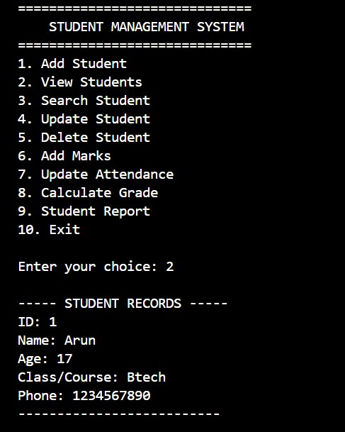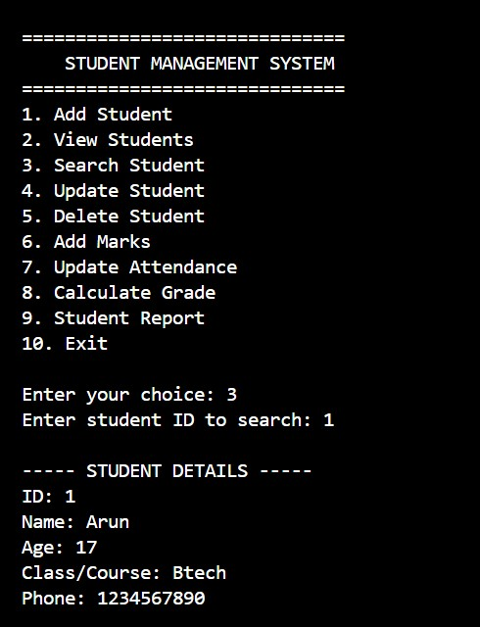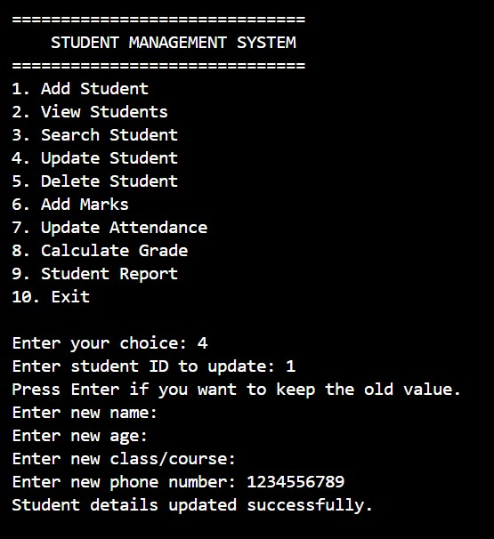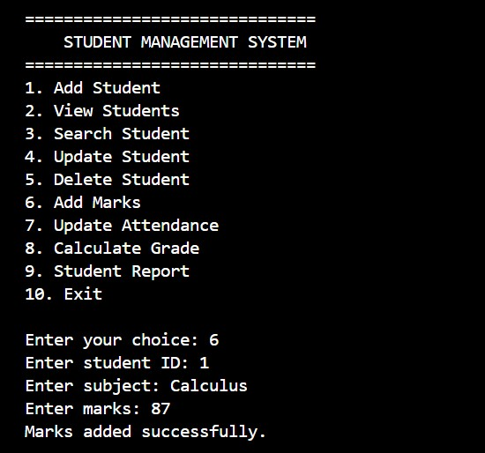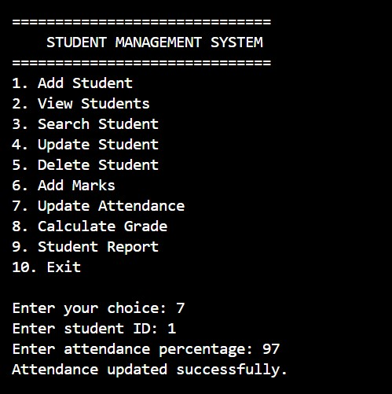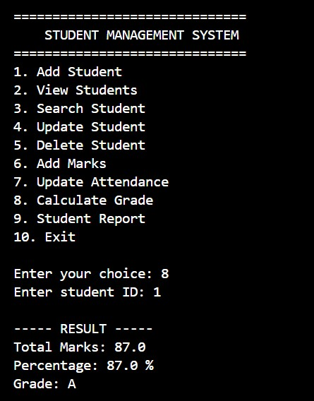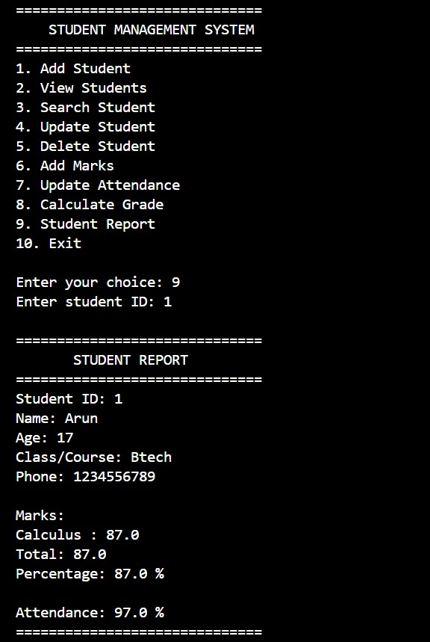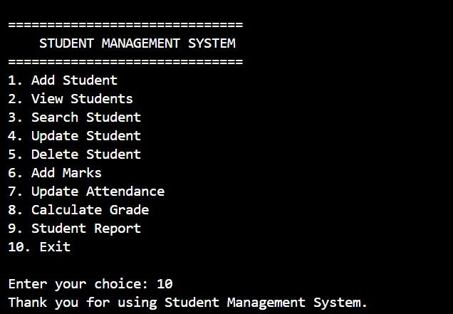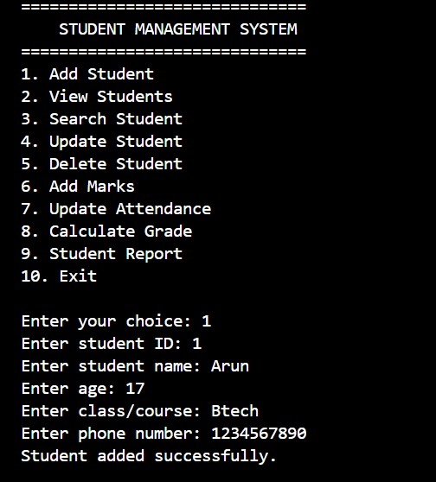

TESTING
Testing was performed to check whether the Student Management System works correctly for different operations and inputs. Each major feature was tested separately to identify errors and verify that the expected output was produced.

Testing Methods
The following testing methods were used:
- Functional Testing – Checked whether each feature performs its intended task.
- Input Testing – Checked the system with valid and invalid inputs.
- File Testing – Checked whether student data is saved and loaded correctly.
- Integration Testing – Checked whether different modules work correctly together.

Test Cases
Test Case | Operation | Input/Action | Expected Result
TC01 | Add Student | Enter valid student details | Student record is added
TC02 | View Students | Select View option | All stored students are displayed
TC03 | Search Student | Enter valid student ID | Correct student record is displayed
TC04 | Search Student | Enter an invalid ID | Student not found message is displayed
TC05 | Update Student | Enter valid student ID and new details | Student information is updated
TC06 | Delete Student | Enter valid student ID | Student record is deleted
TC07 | Marks | Enter valid subject marks | Marks are stored correctly
TC08 | Grade Calculation | Enter valid marks | Percentage and grade are calculated
TC09 | Attendance | Enter attendance details | Attendance is stored and displayed
TC10 | Report | Select report option | Complete student report is displayed
TC11 | File Storage | Close and reopen program | Previously saved records are available
TC12 | Invalid Menu Choice | Enter an invalid option | Appropriate error message is displayed

Testing Result
The major functions of the Student Management System were tested using different inputs. The system successfully performed student registration, searching, updating, deletion, marks management, attendance management, grade calculation, report generation, and data storage.
The testing helped identify and correct basic input and data-handling errors. After testing, the system was able to perform the required operations correctly.

CHALLENGES AND LEARNINGS

Challenges
During the development of the Student Management System, some challenges were faced:
- Managing multiple student records and keeping the data organized.
- Handling invalid inputs without causing the program to stop.
- Implementing search, update, and delete operations correctly.
- Storing and retrieving student data using files.
- Connecting different modules so that they work together properly.
- Calculating marks, percentage, grades, and attendance correctly.
- Testing different situations and finding errors in the program.

Learnings
This project helped in understanding and applying several Python programming concepts:
- Learned how to divide a large program into smaller modules and functions.
- Improved understanding of lists, dictionaries, loops, and conditional statements.
- Learned how to use file handling for storing and retrieving data.
- Understood the importance of input validation and basic error handling.
- Learned how different modules can work together as one complete system.
- Improved debugging and problem-solving skills.
- Learned how to test a

CONCLUSION
The Student Management System was successfully developed using Python to provide a simple and organized way of managing student records. The system allows users to add, view, search, update, and delete student information along with managing marks and attendance.
The project demonstrates the practical use of Python concepts such as functions, loops, conditional statements, data structures, file handling, and basic error handling. The modular structure makes the system easier to understand, test, and maintain.
Overall, the project helped in gaining practical knowledge of Python programming and showed how basic programming concepts can be combined to create a useful real-world application.

